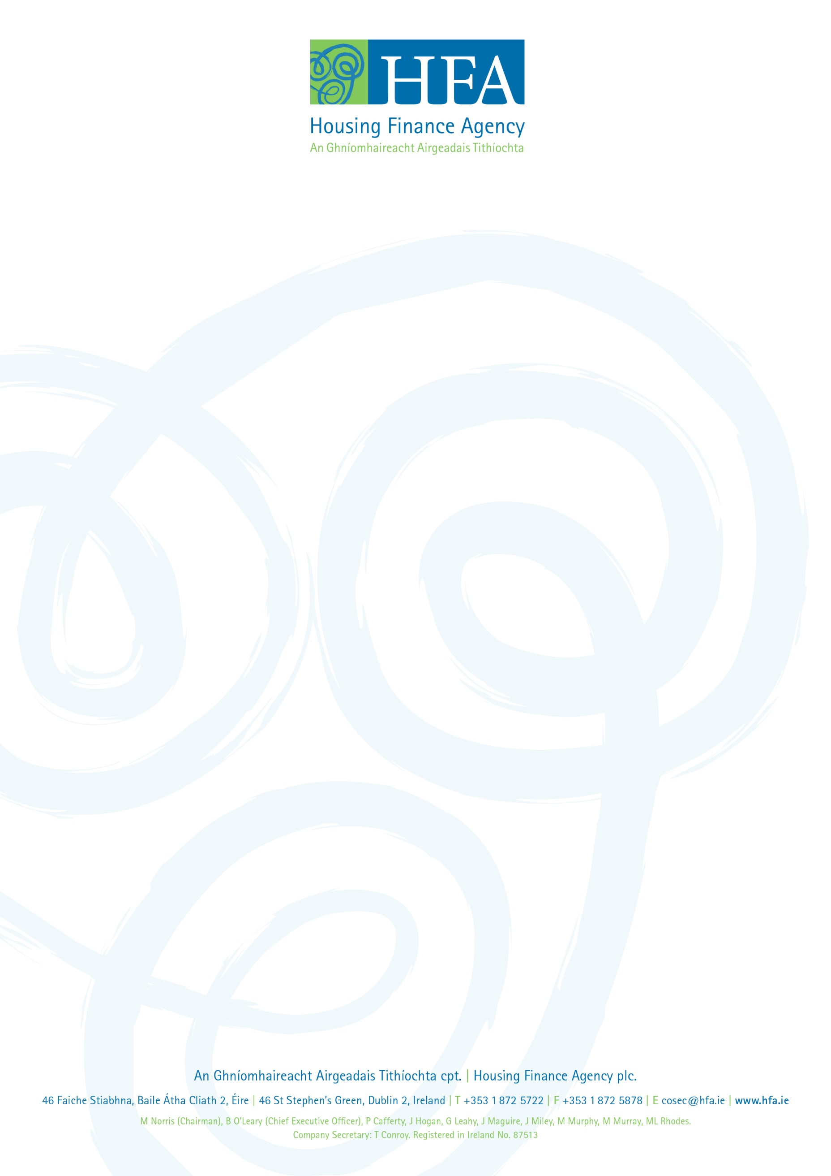

Procurement Policies:
To be updated shortly

